Project Name: E-commerce for farm product mango.



***Mango Crazy***

Brief Summary:

The system introduces, promote and manage mangoes of different variety cutting middle man costs. This system ensures that the end user get the fresh product directly from the farmer for the best market price.

System allow authenticated user to order mangoes of different variety from their places by selecting as per availability mangoes.

Farmers get verified and only verified farmers are allowing to register which will give assurance to customer that they get the good quality mangoes.

Authenticated farmer (seller) will modify the product details and delivery details (drop shipping at seller end) as per availability and status will update on platform.

Admin can access all the functionalities of customer and seller. Admin can monitor order and sales reports.

Actors:

Admin

Customer

Seller (Farmer)

Use Case (Functionality):

Customer:

1)Authentication (login / Registration)

2)view product

3)order product

4)cancel order (condition before dispatch only)

Farmer:

6)add product

7)delivery of product //update on portal reflect on customer and seller side drop shipping service

8)sale of farmer

Admin:

10)view customers

11)view sellers

12)current orders reports

13)total sale

Pages:

1)Home page

2)login/ registration page

3)order page

4)product view page

5)billing page/including all details of user

6)about us with farm pic

7)contact/ help

Product (mangoes selected )

1)Alphonso (The Konkan region comprising Palghar, Thane, Raigad, Ratnagiri and Sindhudurg districts, Maharashtra)

2)Gir Kesar (Junagadh (Around Gir Forest) Gujarat)

3) laxman bhog ( Malda , West Bengal)

4) Dasheri(Lucknow,Uttar Pradesh)

Use Case Diagram:-

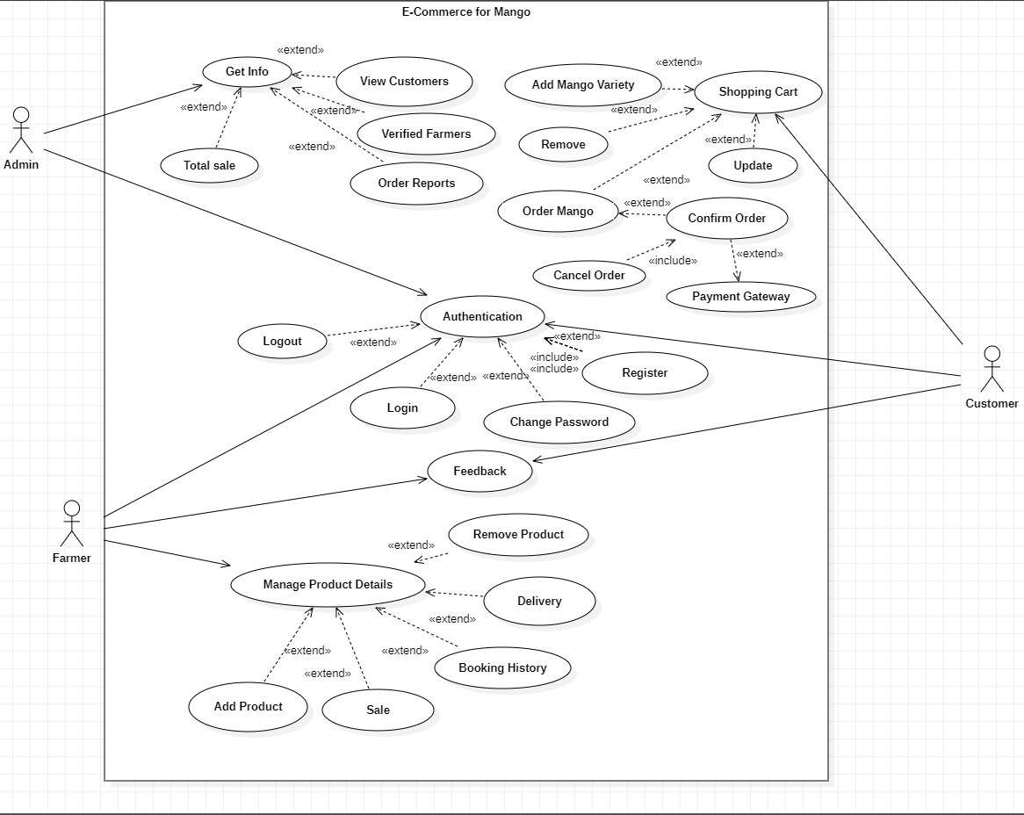

Future Scope: - system provide the business statistic which will help farmer to promote, manage sales data, and can improve performance in sales using PowerBI.